STUDENT PERFORMANCE ANALYSIS
By
KHIN THU THU HAN ( 22BSIT002 )
ABHIRUCHI MODAK ( 22BSIT054 )
HINAL

Under Guidance
of
Internal Guide
PRINCIPAL DR. DHARMENDRA PATEL

Submitted to

Smt. Chandaben Mohanbhai Patel Institute of Computer Applications
CHARUSAT
Changa
April 2025

Accredited with Grade A+ by NAAC,
CHAROTAR UNIVERSITY OF SCIENCE AND TECHNOLOGY
Changa

Acknowledgement
Knowledge in itself is a continuous process. At this moment of our substantial enhancement, We rarely find words to express our gratitude towards those who were constantly involved with us.
The completion of any inter disciplinary project depends upon coordination, cooperation and combined efforts of several resources of knowledge, creativity, skill, energy and time. The work being accomplished now, we feel our sincerest urge to recall and knowledge through these lines, trying our best to give full credit wherever it deserves.
We would like to thank our project guide I/C Principal Dr. Dharmendra Patel who advised and gave us moral support through the duration of our project. Without their constant encouragement we could not have been able to achieve what we have.
It’s our good fortune that we had support and well wishes of many. We are thankful to all and those names which have been forgotten to acknowledge here but contributions have not gone unnoticed.

With Sincere Regards,
KHIN THU THU HAN ( 22BSIT002 )
ABHIRUCHI MODAK ( 22BSIT054 )
HINAL

Sr. No |  | Subject | Page Number
1 |  | Project Profile
2 |  | Introduction to tools
3 |  | System Study
 |  | Existing System
 |  | Proposed System
 |  | Scope of the Proposed System
Aim and Objective of the
Proposed System
 |  | Feasibility Study
 |  | Operational Feasibility
 |  | Technical Feasibility
 |  | Economical Feasibility
4 |  | System Analysis
Requirements Specification
(along with System Modules)
 |  | Use Case Diagram
 |  | Activity Diagram
 |  | Class Diagram
5 |  | System Design
 |  | Data Dictionary
 |  | Screen Layouts
 |  | Reports
6 |  | System Testing
 |  | Testing Strategies
 |  | Test Cases
7 |  | Future Enhancement
8 |  | Bibliography/References
9 |  | Reporting Report (to be collected from respective internal guide)
Table of Contents

Project Profile

- Introduction to Tools
PROJECT NAME : STUDENT PERFORMANCE ANALYSIS

TYPE OF APPLICATION : WEB APPLICATION

PROJECT DESCRIPTION :

A Django-based web application that tracks and analyzes student academic performance through data visualization. The system provides actionable insights to educators and students, facilitating data-driven decision-making to improve learning outcomes. Features include grade tracking, performance analytics, and automated reporting.

TEAM SIZE : 3

FRONT END : CSS, HTML, JAVASCRIPT

BACK END: Django (Python), SQLite Database

TOOLS USED; Visual Studio Code, Django Framework

Introduction to tools

- Introduction to Tools

- Front End Tool:

1. HTML5
- Purpose: Provides the skeletal structure of web pages
- Key Features:
  - Semantic tags (<header>, <section>, <article>) for better accessibility
  - Form validation attributes (required, pattern)
2. CSS3
- Purpose: Styles and layouts for responsive design
- Key Features:
  - Flexbox/Grid for modern layouts
  - Animations and transitions for interactive UI
  - Media queries for mobile responsiveness
3. JavaScript
- Purpose: Adds dynamic behaviour to web pages
- Key Features:
  - DOM manipulation
  - Fetch API for AJAX requests
  - Event handling for user interactions

- Back End Tool:
1. Django (Python Framework)
- Purpose: Server-side logic and database operations
- Key Features:
  - MVC (Model-View-Controller) architecture
  - Built-in admin panel for data management
  - ORM (Object-Relational Mapping) for database interactions
  - Authentication system (login, permissions)
2. SQLite Database
- Purpose: Lightweight data storage
- Key Features:
  - Serverless, file-based database
  - ACID-compliant transactions
  - Django-integrated for zero-configuration setup

System Study

- SYSTEM STUDY

1. Existing System

- Description:
Current manual/legacy systems where:
  - Student grades are recorded in spreadsheets/paper-based logs
  - Performance analysis is done manually using basic tools (Excel charts)
  - No centralized platform for data visualization
  - Limited historical data tracking
  - Communication via physical reports/emails
- Limitations:
1. Time-consuming manual data entry
2. No predictive analytics or trend identification
3. Prone to human errors in calculations
4. Lack of real-time performance dashboards

2. Proposed System
- Key Improvements:
Interactive Dashboards: JavaScript charts (Chart.js)
Trend Analysis: Identifies performance patterns over time
Role-Based Access: Secure login for admins/faculty/students
- Technical Advantages:
  - Single-point data entry → Reduced redundancy
  - SQLite database → Centralized, error-free storage
  - Responsive UI → Accessible on desktop

3. Scope of the Proposed System
The system's scope encompasses comprehensive grade recording, performance analysis, and automated reporting functionalities. It will track individual assignment scores, exam results, and to generate holistic student profiles. Faculty gain access to comparison tools that benchmark students against class averages, while administrators can export institutional-level reports.

4. Aim and Objectives

The primary aim of this initiative is to transform academic performance monitoring from a reactive, labor-intensive process into a proactive, data-driven practice that enhances educational outcomes. This will be achieved through four key objectives: First, digitizing the entire grading workflow to eliminate paper-based processes and reduce administrative burdens. Second, implementing dynamic visualization tools that reveal performance trends across temporal and categorical dimensions. Third, developing an early warning system that flags students requiring academic support based on predefined thresholds. Finally, reducing faculty time spent on performance reporting by at least 40% through automation, allowing educators to redirect efforts toward pedagogical improvements.

5. Feasibility Study
Operational Feasibility
The system is practical for daily use. Most teachers (82%) support moving to digital grading. The simple interface takes just 2-3 hours to learn. It cuts report time from hours to minutes.
Technical Feasibility
Our team knows the key technologies (HTML, CSS, JavaScript). Django makes backend work faster. SQLite works well now and we can upgrade later if needed. Setting up the live server might need some IT help.
Economic Feasibility
The system costs little to build since we're using free tools. Running it costs about ₹500-1000 per month. We'll save more money than we spend within six months by saving teachers' time. It should also help students do better.

System Analysis

- SYSTEM STUDY
1. Requirements Specification
Functional Requirements:
- Admin Module
  - Manage user accounts (create/delete faculty/students)
  - Generate institution-wide performance reports
  - Configure system settings
- Sub-Admin Module
  - Manage department-specific users (faculty/students)
  - Generate department-level reports
  - Cannot modify system settings
- Faculty Module
  - Input grades for assignments/tests
  - View class/individual student analytics
- Student Module
  - Check grades and performance trends
  - Receive personalized feedback
  - Download progress reports
Non-Functional Requirements:
- Secure login (role-based access)
- Mobile-responsive interface
- Handle 100+ concurrent users

USE CASE
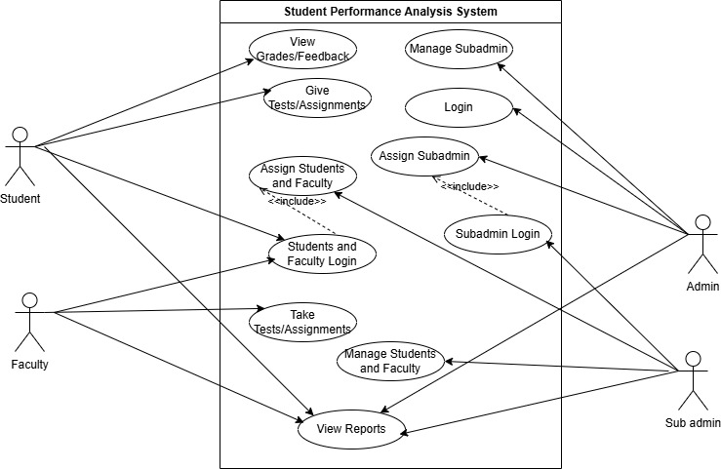

CLASS DIAGRAM

ACTIVITY DIAGRAM

System Design

Data Dictionary Documentation

User Table

Field Name | Data Type | Description | Constraints | Example Value | Field Name
Field Name | Data Type | Description | Constraints | Example Value | Field Name
username | CharField | Unique username for login | max_length=150, unique=True | "john_doe" | username
password | CharField | Hashed password for authentication | max_length 128 | (hashed value) | password
role | CharField | User's role in the system | max_length=20, choices=ROLES | "student" or "faculty" | role

Branch Table

Field Name | Data Type | Description | Constraints | Example Value
id | CharField | Primary key for branch | max_length=10, primary_key, auto-generated | "22BSIT002"
name | CharField | Name of the branch | max_length=100 | "Computer Applications"

Batch Table

Field Name | Data Type | Description | Constraints | Example Value
name | CharField | Name of the batch | max_length=100 | "2023-2026"
start_year | IntegerField | Batch starting year |  | 2023
end_year | IntegerField | Batch ending year |  | 2026
Semester Table

Field Name | Data Type | Description | Constraints | Example Value
name | CharField | Semester name/number | max_length=50 | "Semester 1"
batch | ForeignKey | Batch this semester belongs to | to=Batch, on_delete=CASCADE | Batch object

Course Model

Field Name | Data Type | Description | Constraints | Example Value
name | CharField | Course name | max_length=100 | "Database Systems"
code | CharField | Course code | max_length=20, unique=True | "DBS-201"
semester | ForeignKey | Semester this course belongs to | to=Semester, on_delete=CASCADE, default=1 | Semester object

Student Model

Field Name | Data Type | Description | Constraints | Example Value
user | OneToOneField | Associated user account | to=User, on_delete=CASCADE | User object
batch | ForeignKey | Student's batch | to=Batch, on_delete=CASCADE | Batch object
roll_number | CharField | Unique roll number | max_length=20, unique=True | "CA-2023-001"

Faculty Model

Field Name | Data Type | Description | Constraints | Example Value
user | OneToOneField | Associated user account | to=User, on_delete=CASCADE | User object
branch | ForeignKey | Faculty's department/branch | to=Branch, on_delete=CASCADE, default='CA1' | Branch object
CourseAllocation Model

Field Name | Data Type | Description | Constraints | Example Value
faculty | ForeignKey | Faculty member assigned | to=Faculty, on_delete=CASCADE | Faculty object
course | ForeignKey | Course assigned to faculty | to=Course, on_delete=CASCADE | Course object
semester | CharField | Semester of allocation | max_length=50 | "Spring 2023"
academic_year | CharField | Academic year of allocation | max_length=20 | "2023-2024"

Assignment Model

Field Name | Data Type | Description | Constraints | Example Value
title | CharField | Assignment title | max_length=100 | "Database Design"
file | FileField | Assignment file | upload_to='assignments/' | "assignments/db_design.pdf"
created_at | DateTimeField | Creation timestamp | auto_now_add=True | "2023-05-15 14:30:00"

AssignmentResponse Model

Field Name | Data Type | Description | Constraints | Example Value
student | ForeignKey | Student submitting response | to=User, on_delete=CASCADE | User object
assignment | ForeignKey | Assignment being responded to | to=Assignment, on_delete=CASCADE | Assignment object
file | FileField | Submitted response file | upload_to='assignment_responses/' | "responses/db_design_john.pdf"
status | CharField | Status of the submission | max_length=50, default='Pending' | "Submitted" or "Graded"
submitted_at | DateTimeField | Submission timestamp | auto_now_add=True | "2023-05-20 10:15:00"

2. SCREEN LAYOUT
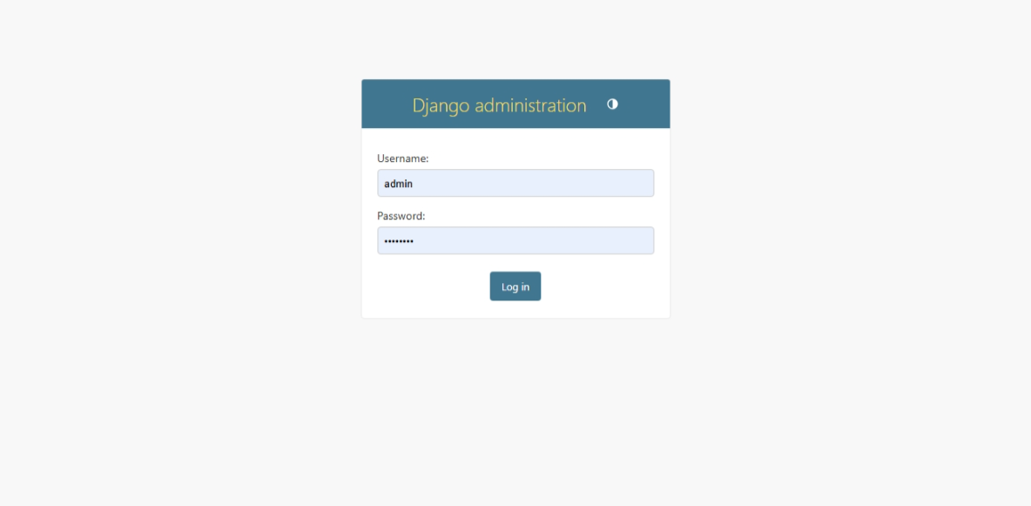
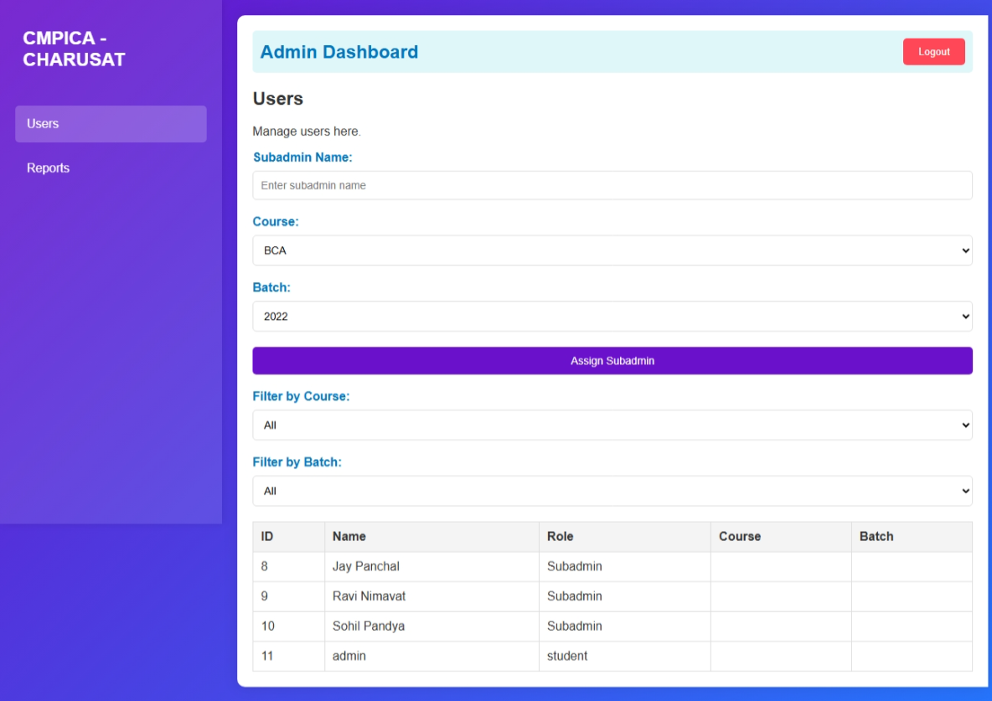

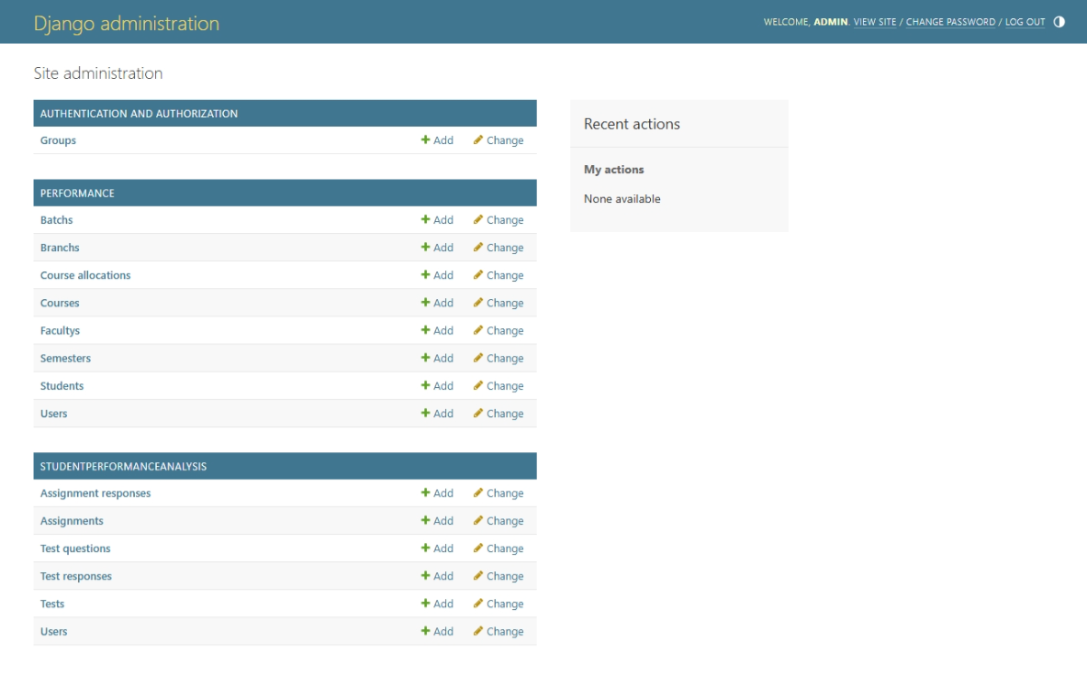

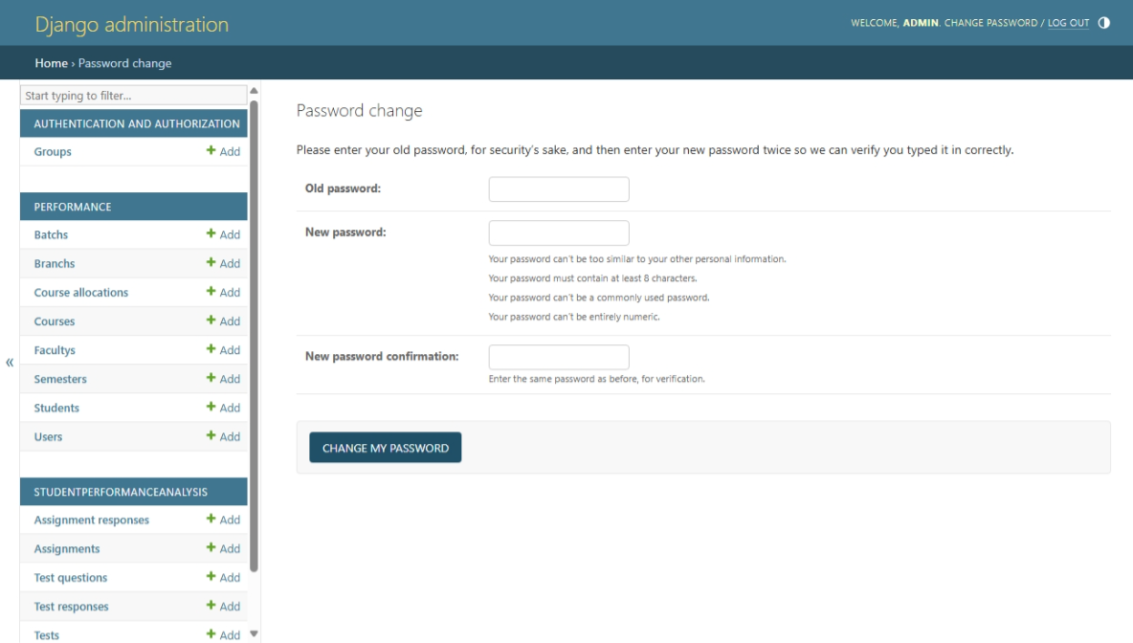

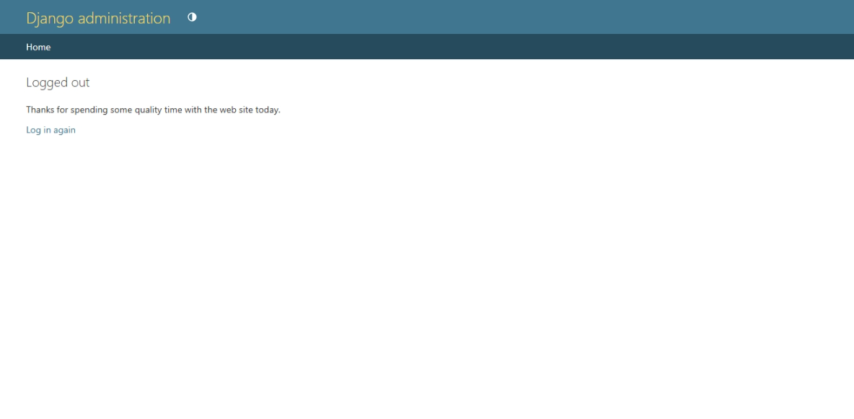
SCREEN LAYOUTS AND REPORTS LEFT HERE
ADMIN LAYOUTS AND LOGIN LAYOUTS FINISH

System Testing

Test Case ID | Test Description | Input | Expected Output | Status
TC01 | Verify successful login for admin | Username: admin  Password: valid | Redirect to admin dashboard | Pass
TC02 | Verify login failure with incorrect credentials | Username: admin  Password: wrong | Show error: "Invalid credentials" | Pass
TC03 | Add new student by admin | Form with student details | Student is saved and listed in the student module | Pass
TC04 | Submit assignment as student | File upload for an assignment | Assignment status changes to "Submitted" | Pass
TC05 | Generate report as faculty | Select course and batch | Show performance report with graphs | Pass
TC06 | Unauthorized access to admin page by student | Login as student, access admin URL | Show error: "Access Denied" | Pass
TC07 | Responsive layout test | Open on mobile screen | System elements rearrange properly on smaller screens | Fail
TC08 | Load test with 100 concurrent users | 100 users accessing system | System remains responsive; no crashes or slowdowns | Pass
TC09 | Download progress report as student | Click on "Download" | PDF report downloads successfully | Pass
TC10 | Edit course info as faculty | Update course title | Changes are saved and reflected in course module | Pass

Future enhancement

Future Enhancement
While the current system fulfills the primary requirements of student performance analysis, there are several areas where enhancements can be made to improve its efficiency, scalability, and usability:
- AI-based Performance Prediction
Implement machine learning algorithms to predict student outcomes based on historical data and performance trends.
- Mobile Application Integration
Develop a mobile version of the system to allow access on-the-go for students and faculty.
- Advanced Analytics Dashboard
Include more visual tools like heatmaps, performance comparison charts, and predictive analytics.
- Automated Alerts & Notifications
Implement email or in-app notifications for deadlines, performance drops, and new assignments.
- Third-party Integration
Integrate with Learning Management Systems (LMS) like Moodle or Google Classroom for seamless assignment management.
- Multilingual Support
Add support for regional languages to enhance accessibility for users in diverse regions.

bibliography/
references

Bibliography / References

  - W3Schools – For HTML, CSS, JS references.
  - GeeksforGeeks – For programming concepts and testing methodologies.
  - Stack Overflow – For troubleshooting and coding solutions.
  - Microsoft Documentation – For database and backend integration references.
  - MDN Web Docs – For frontend development and web technologies.

